Software Requirements Specification

<<first commit>>

Version 1.0

<<?? >>

May 17,2021

System maintenance and operation company

Malaz Teamleader

Noor Altabbal

Ola Almasri

Submitted in partial fulfillment

Of the requirements of

CS 310 Software Engineering

1. **Introduction** 
   1. ***Purpose***

In this document we present a description of the maintenance company management system, where a system is developed to fully automate the work and in order to abandon the data paperwork system, it will explain the purpose of the system and its features, the system interfaces, what the system will do, the restrictions that it must operate under and how the system will interact With external stimuli.

***1.2. Scope of Project***

This software system will be a Web Publishing System for provide a description of the automation system for a maintenance and operation company (refrigeration and air conditioning), Which in turn works to maintain all types of devices such as conditioning and others , As some employees coordinate the export operations of all kinds of parts needed for work and maintain them until they are used when needed, and some are responsible for maintaining parts to avoid breakdowns for customers' devices, so the need to develop them to be easier and more comfortable to manage and to provide a smooth and flexible work environment for employees away from the resulting complexity for paperwork.

A computer network is equipped in line with all types of employees (managers, workers, human resources specialist) for the various tasks in the company and takes into account the responsibility of each employee separately, so that until the employee enters the company, he must cross the electronic portal that reads the employee's ID code from his smart card, and there is the executive director The maintenance manager is in addition to the workers whose responsibilities are integrated to complete the tasks required for the company.

***1.3. Glossary***

|  |  |
| --- | --- |
| **Definition** | **Term** |
| t means receiving customer requests through various means of communication and dealing with customers, directly or indirectly, to respond to their questions and inquiries. | Call Center |
| Human resources is concerned with managing the people in the company through specific methods and strategies that raise the performance of employees and solve work problems. | Human Resource (HR) |
| What distinguishes the HR professional is the ability to analyze, evaluate, visualize and follow up. | Human Resource Specialist (HRS) |
| A worker is an employee, but he does not have any certificates, but a person with professional experience and he has an employee supervising him | Worker |
| An employee is a person who was appointed based on his testimonials and experiences together and supervises a class of workers according to his specialization, he can be a manager or a supervisor or HRs. | Employee |
| A customer is anyone who owns a device that has broken down and needs to be repaired. | Client |
| Collection of all the information monitored by this system. | Database |
| It consists of two copies of the request email, one for the employee who must do the work and the other for the concerned manager (i.e., sending the email to the concerned party.) | CC |
| A document that completely describes all of the functions of a proposed system and the constraints under which it must operate. For example, this document. | Software Requirements Specification |
| Employee , Worker and Client | User |

***1.4. References***

IEEE. *IEEE Std 830-1998 IEEE Recommended Practice for Software Requirements Specifications.* IEEE Computer Society, 1998.

***1.5. Overview of Document***

The next chapter, the Overall Description section, of this document gives an overview of the functionality of the product. It describes the informal requirements and is used to establish a context for the technical requirements specification in the next chapter.

The third chapter, Requirements Specification section, of this document is written primarily for the developers and describes in technical terms the details of the functionality of the product.

Both sections of the document describe the same software product in its entirety, but are intended for different audiences and thus use different language.

1. **Overall Description**

***2.1 System Environment***

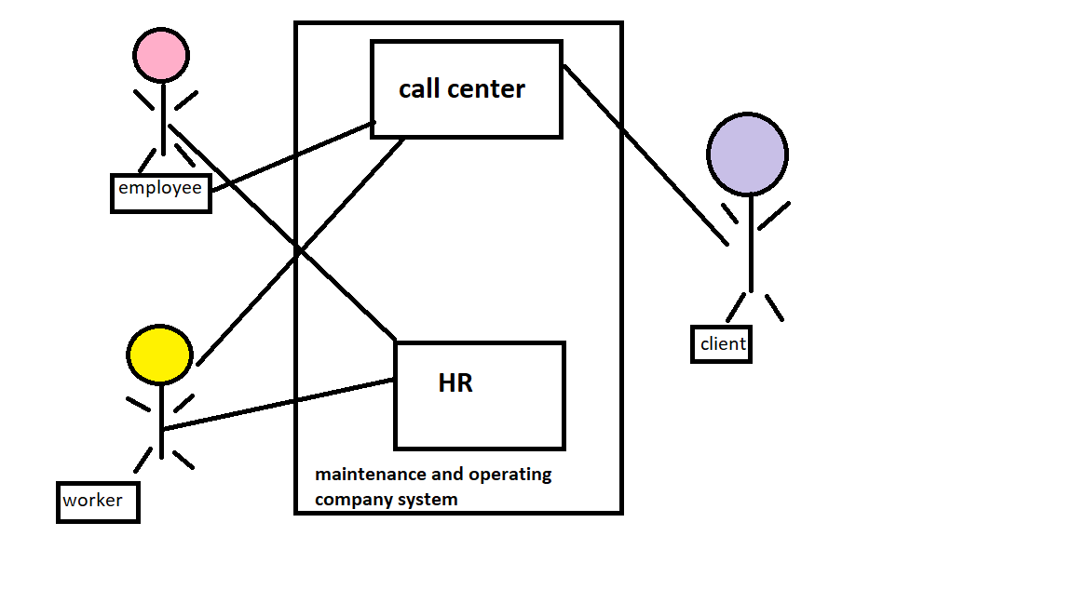

***2.2 Functional Requirements Specification***

This section outlines the use cases for each of the active employee separately. The employee, and the worker have only one use case apiece while the HRs is main actor in this system.

2.2.1 Employee HRs Use Case

Use case: **Entering new Employee data**

**Diagram:**

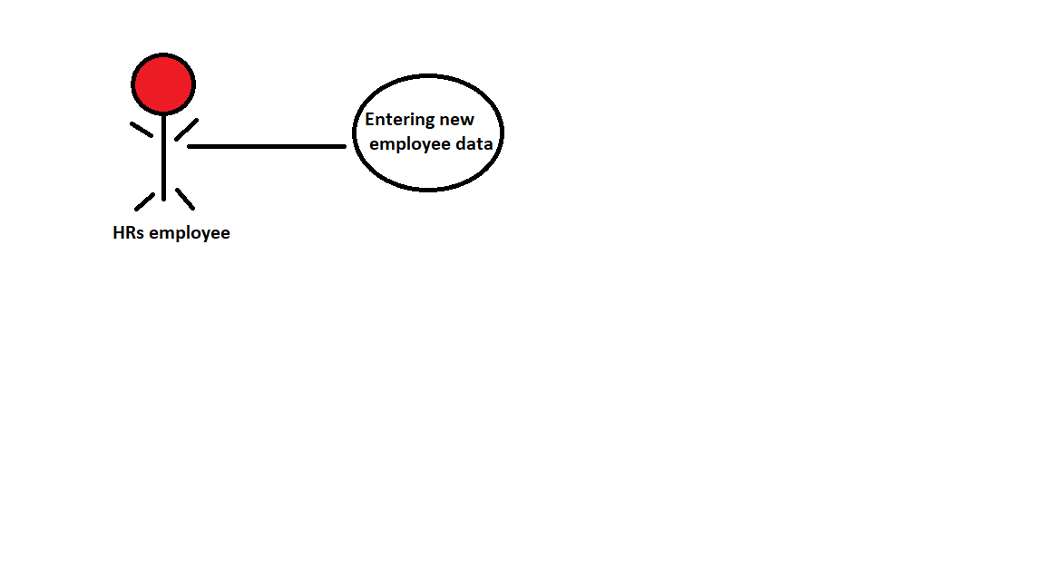

**: Brief Description**

The HRs employee receives the employment application that contains all the information and details and records it in the company's records.

**Initial Step-By-Step Description:**

Before this use case can be initiated, the HRs employee must check the information and interview the new employee .

The HRs employee hires the new employee in a department that he specialized at 1-

2-Gives him an ID card that has his name and specialty which qualifies him to join the company.

3-Puts some workers under his supervision.

4-Creates the employee's a company account.

5-Sends all the company's rules and conditions that he has to follow.

**Xref** : section 3.2.1 **Entering new Employee data**

**2.2.2 Client Use Case**

Use case: Repair request

**Diagram:**

**Client**

**Brief Description:**

The customer requests the service from the call center with giving all the necessary details about the malfunctioning device and specifying the address

**Initial Step-By-Step Description:**

Before starting this case, you must know the type of malfunction in order to explain and inform the company of the type and name of the device.

1. The supervising engineer shall be informed of all the problems that occurred in the device, so that the engineer can determine the type of malfunction.
2. After the completion of the repair, the customer transfers the amount of the repair to the company's account after an invoice reaches him with all the amounts obligated.

**Xref:** Section 3.2.2, : **Repair request**

**2.2.3 Call Center Employee**

Use case: **Receive a maintenance request**

**Diagram:**

**Call Center**

**Brief Description:**

The call center employee answers the customer’s calls and understands from him about the malfunction status information and the customer’s location to record the data and details in the e-mail and send it to the parties concerned with the request.

**Initial Step-By-Step Description:**

Before this case begins, the Call Center employee must prepare all communication lines for quick response and verify the customer’s identity and information.

1. The employee sends the email to the engineer employee concerned with the request, specifying the type of parts needed.
2. Transferring the email at the same time to the CEO using the so-called CC.

**Xref:** Section 3.2.3, **Receive a maintenance request**

* + 1. **Employee Worker Use Cse**

Use case: Fix a broken device

**Diagram:**

Worker

**Brief Description:**

The worker receives instructions and all the details from the supervising engineer in order to be ready to do the work The worker receives instructions and all the details from the supervising engineer in order to be ready to do the work.

**Initial Step-By-Step Description:**

Before starting this case, the worker must prepare all the required tools and also prepare a car from the company's cars in the event that it is decided to go to the specified site directly.

1. The worker gets all the information from the supervising engineer about the malfunctioning device to bring all the supplies and readiness to go to the work site.
2. Replacing the old piece with a new one and repairing the device sufficiently under the supervision of the supervising engineer.

**Xref:** Section 3.2.4, **Fix a broken device**

* 1. ***User Characteristics***

Any employee must have certificates: that is, he must be an engineer with a degree (mechanical, electrical, electromechanical) or a graduate of an institute (electrical or air conditioning).

He must have knowledge of the Internet and dealing with the computer

As for the worker, he must have experience of no less than five years and also have prior knowledge of the Internet.

* 1. ***Non-Functional Requirements***

The company will have a system equipped with a computer network, and the IT department responsible for processing e-mails will be activated and all documents related to employees will be kept in their own files with complete confidentiality.

A system that includes CALL CENTER management, security surveillance (surveillance cameras), and the company's security and electronic protection.

With accuracy in work:

Accuracy in data related to human resources and administrative affairs.

Accuracy in applying the approved laws and regulations.

Ensure that the documents are correct.

Ensure the correctness of documents related to the administrative affairs activity.

Speed:

Implementation of the company's services.

Implementing services for employees.

Interact with events and emergencies.

1. **Requirements Specification**

***3.1 External Interface Requirements***

The system must provide the ability to do all the work for its users that the employees carry out , Where calls are received from customers through customer service (using a unified number ID) ,The call is made via e-mail (it is the process of receiving a maintenance request.

The email is transferred to the authority concerned with maintenance, for example (TEAM MOBILE or the air conditioning team), that is, according to the concerned team of the request (where the type of parts required and suitable for work is specified in the request), then the transfer is made via an official email belonging to the employer(Coming from CALL CENTER )

The CC is sent (it is two copies of the request email, one of which is to the employee who must do the work and the other to the concerned manager (i.e., to send the email to the concerned party))

**A clear note:** what is meant by the word “CC” is a carbon copy, that is, inside this field they can write postal addresses in order to send the same message to them.

With directing the technicians to the work site and carrying out the required work by activating the GPS location service using the company's cars and sending another e-mail to inform about the end of the work execution, it is sent to (CALL CENTER) and sent to the managers. The last e-mail contains all the details (the cost and type of repair, the number of the office or the apartment in which the work was done.

***3.2 Functional Requirements***

The Logical Structure of the Data is contained in Section 3.3.1

3.2.1 Entering new employee data

|  |  |
| --- | --- |
| Entering new employee data | **Use Case Name** |
|  | **XRef** |
| The employee submits a job application to the company. | **Trigger** |
| Required certificates and experiences | **Precondition** |
| 1-Provide the employee with his C.V that contains all his personal information.  2- Conducting the interview with the employee to determine the competencies.  3- If accepted, an ID number will be given with a smart card  4- It is sorted in the company's departments according to his certificates.  5- Informing him about the manner and nature of work, including times, wages, etc. | **Basic Path** |
| In the event that the appropriate conditions for the new employee are not met, it will be rejected. | **Alternative Paths** |
| Giving the employee a smart card containing the id number and adding his record to the employee records | **Postcondition** |
| The employee can cancel the submission request at any time | **Exception Paths** |

**3.2.2 Receive a maintenance request**

|  |  |
| --- | --- |
| Receive a maintenance request | **Use Case Name** |
|  | **XRef** |
| A maintenance request from the customer. | **Trigger** |
| Availability of communication lines with the company to receive a request from the customer. | **Precondition** |
| 1-Receiving a maintenance request from the customer to the Call Center.  2- Sending an email from the Call Center to the concerned authority at work.  3- Sending the concerned team to the place of maintenance by using the GPS service.  4- Notifying the end of work by sending an email to the managers and the Call Center (with all the details included if the work was done or not). | **Basic Path** |
| The customer comes to the company to submit the request. | **Alternative Paths** |
| Send an email on the request to the concerned party | **Postcondition** |
| None. | **Exception Paths** |

**3.2.3 Repair request**

|  |  |
| --- | --- |
| Repair request | Use Case Name |
|  | **XRef** |
| The customer makes a phone call to the company | **Trigger** |
| The company's lines are ready to receive calls from customers. | **Precondition** |
| The customer comes to the company to submit a repair request in case his calls are not answered. | **Basic Path** |
| 1- The customer provides the supervising engineer and the workers with all the details of the device.  2- Informing the supervising engineer about all the problems that occurred with the device to be able to determine the type of malfunction. | **Alternative Paths** |
| Transferring the amounts incurred by him to the company’s account after receiving an invoice from the company. | **Postcondition** |
| None. | **Exception Paths** |

**3.2.4 Fix a broken device**

|  |  |
| --- | --- |
| Fix a broken device | Use Case Name |
|  | **XRef** |
| Send the required piece based on the customer's request. | **Trigger** |
| Inquire about the type of segment required after determining the type of the customer's hardware failure | **Precondition** |
| 1-After receiving a maintenance request from the customer, the responsible employee is sent with his supervising workers to the customer’s site to check the status of the malfunctioning device and know the type of piece that needs to be provided.  2-When determining the type of part, its type and cost are recorded, and then the customer is informed of all the details by the responsible employee for approval.  3-Send the required piece, if available and installed. | **Basic Path** |
| In the event that the part is not present, a suitable replacement part will be sent to the defective device, or the customer must wait for the responsible employee to send an import request for the part from the manufacturer. | **Alternative Paths** |
| The possibility of installing the appropriate part for the customer's device after the customer has agreed to all the details and conditions. | **Postcondition** |
| None. | **Exception Paths** |

***3.3 Detailed Non-Functional Requirements***

3.3.1 Logical Structure of the Data

The logical structure of the data to be stored in the internal Article Manager database is given below.

Employee

Supervise on

Directed

Client

Recive an order

Call Center

Worker

Select a type

Parts

**Figure (?) - Logical Structure of the Article**

The data descriptions of each of these data entities is as follows:

**Employee Data Entity**

|  |  |  |  |
| --- | --- | --- | --- |
| **Comment** | **Description** | **Type** | **Data Item** |
|  | The employee identification number for the company | Integer | ID |
|  | Department employee | Text | Call Center |
|  | The name of the employee responsible for the service | Text | Full name |
|  | Male / Female | Text | Gender |
|  | The date of the employee's appointment in the company | Date | Goining Date |
| May be several | The scientific certificates obtained by this employee | Text | Type Of Certificate |

**Worker Data Entity**

|  |  |  |  |
| --- | --- | --- | --- |
| Comment | Description | Type | Data Item |
|  |  | Text | Full Name |
|  | The name of the employee in charge of the worker | Text | Employee |
|  | The number of years of work experience | Number | Experience |
|  |  |  |  |

**Client Data Entity**

|  |  |  |  |
| --- | --- | --- | --- |
| Comment | Description | Type | Data Item |
|  | Customer Number | Interger | Number |
|  |  | Text | Full Name |
|  | The address of the customer that the employee will specify via GPS to go to him and check the device | Text | Address |
|  |  | Text | Type Of Malfunction |

**Call Center Data Entity**

|  |  |  |  |
| --- | --- | --- | --- |
| Comment | Description | Type | Data Item |
|  |  | Interger | Number |
|  | The employee identification number in this section | Integer | Employee ID |
|  | Internet address | Text | Email |
|  | Part numbers in the company | Integer | Part ID |
|  | Number of clients dealt with | Integer | Client Number |

**Part Data Entity**

|  |  |  |  |
| --- | --- | --- | --- |
| Comment | Description | Type | Data Item |
|  |  | Integer | Part Name |
|  | The number of the part in the company | Text | Part ID |
|  | The price of each piece | Text | Cost |
|  |  | Text | Release Date |
|  | Manufacturer name for each piece | Text | Manufacture company |